ENHANCEMENT AND VALIDATION OF SOLUTIONS FOR HARBOR AND FORCE PROTECTION
João Pedro Correia dos Reis, Paulo Sousa Dias, Gil Gonçalves
LSTS – Underwater Systems and Technology Laboratory
FEUP – Universidade do Porto - Faculdade de Engenharia
Rua Dr. Roberto Frias s/n, I204
4200-465 Porto, Portugal
{ei07119, pdias, gil}@fe.up.pt

Abstract
The development and real warfare application of strategies and individual behaviors is hampered by its life-threatening and multiple situations that should be validated. Simulation is a common process used in this type of circumstances due to the modeling of real life situations along with all entities that make part of it. Latency of events, waiting time between strategies development and its testing in real life, entails in longer waiting times, which is usually an important parameter. The usage of a DSS (Decision Support System) along with a Simulation environment is the approach used for the simulation of surveillance systems, producing a result which is a quality measure of the configurations being tested.
SAFEPORT is a project that aims to develop an application that will help the selection of the best configuration of surveillance systems for harbor and force protection. The main component is the DSS. One of the components of the DSS will simulate the behavior of surveillance system and possible threats. These elements span from human arm forces units, to sensors, unmanned systems, and vessels. The simulation will use several configurations of the defensive elements (proposed by the optimization algorithms) against different kinds of attacks under various environmental conditions in a specific operational scenario. These simulations will help to enhance the proposed solutions and, at the same time, feed the DSS with the results of the several solutions targeting different metrics.
This paper will present and discuss an architecture for this simulation environment. The proposed architecture will follow a multi-agent simulation environment in order to mimic the several elements behaviors and account for the scalability of the system. Due to the complexity of models that are used in the simulation scalability is a major concern. Inputs will be the harbor set and the deployment of the defensive elements as well as the attack strategy. The scenario will play out and then the output with the result of the run will feed the DSS.
The final result of the SAFEPORT project will be made available to the NATO partners for planning the best defense configurations to force protection in a port or harbor environment.
- Introduction
NATO SAFEPORT is a project that targets to assist in the selection of the best configuration of surveillance systems for harbor and force protection, which can be used in multiple scenarios. The main component is the DSS (Decision Support System) [1] that will output, for any given scenario, an adequate set of solutions (selection of available assets, configuration and missions) that maximizes the number of threats detected (or minimizes certain risks), considering available assets, user and environment’s conditions, predictable threats and constraints. For this, a simulation tool is needed in order to play out the scenarios with the different configurations to be tested. These simulations will help to enhance the proposed solutions and, at the same time, feed the DSS with the results of the several solutions targeting different metrics.
The modeling and simulation of military environments has a great impact in how strategies should be applied, how assets should be used for the protection and surveillance in warfare theory, and the validation of communication between entities involved in the process.
The most successful known solutions were presented by F. W. Lanchester and Epstein [14], early in twentieth century, using differential equations for modeling military environments and strategies in warfare. These approaches are still being used, but nowadays there are more efficient, effective and more appropriate tools to reach better results. One of them has to do with multi-agent systems (MAS). This approach was implemented and its architecture described in this paper. We use the JADE framework [17] in this work. JADE (Java Agent DEvelopment) framework provides an implementation of FIPA (Foundation for Intelligent Physical Agents) communication protocol [8] and an interface for both agent and multi-agent architecture. Its advantages span from independence in environment and agent modeling. This allows reaching a more realistic simulation by focusing the strategies in an individual way and not in taking into account the whole architecture. This last advantage is very helpful due to its possibility of creating new behaviors by only changing a few actions in a single agent. The communication is also an advantage in this type of approach, which could provide an adaptation of each agent behavior according to the changing of others [9].
This paper explains the application developed for the simulation of surveillance systems for harbor and force protection, by using the modeling of two different kinds of forces: Red Team and Blue Team. The Red Team is intended to break the surveillance system, testing if Blue Team has the capability to protect a certain area. A multi-agent architecture was used in the implementation of this kind of simulation environment. The following sections will present the architecture, the communication protocol, the simulation process, and the conclusions of the first implementation.
2.0 Multi-agent system
Multi-agent systems can be defined as a set of agents that interact in a common environment, having the ability of changing themselves and the environment [7]. A multi-agent system can be seen as a society, which a set of coexisting independent entities, reaching its goals, using its cooperation and communication skills, like interaction, perception, adaptation and mobility. This type of system has the capability of solving its own problems by interacting to achieve its objectives [13]. Another definition of multi-agent system involves a flexible web of responsible entities aiming the problem resolution, working as a group to obtain a collective answer which is beyond the individual knowledge of each entity [3]. Figure 1 represents some important characteristics like an interactive environment where entities are inserted in, indirect communication through each visibility and influence circle, and direct communication by the organizational relationship and interaction links. These communications are a good representation of real world where entities are neither omnipresent, neither omniscient.
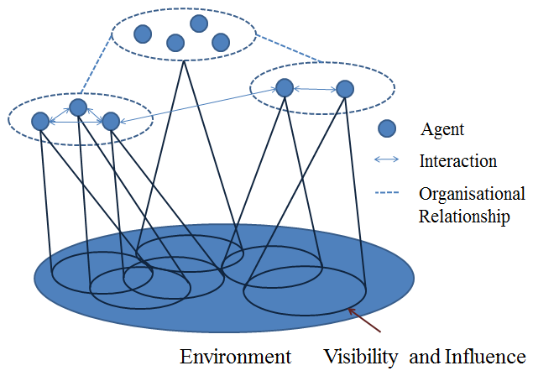
Figure 1: Multi-agent System [10]
For the correct implementation of a Multi-agent System, the following six topics should be taken into account [6]:
- An environment that is usually a space;
- A set of objects that at a given moment could be possible to associate any object with a position;
- An assembly of agents, which are specific objects and represent the active entities in the system;
- An assembly of relations that link objects to one another;
- An assembly of operations making it possible for the agents to perceive, produce, transform, and manipulate; and
- Operators with the task of representing the application of these operations and the reaction to the world.
It is known that the architecture and agents must be specific for each presented problem; hence these topics constitute the cornerstones of MAS that should provide an approximation of real world dynamics, and have to be implemented and modeled in order to reach a valid solution.
3.0 agent
The definition of agent varies in ranges of context, assuming different functions and purposes in areas like philosophy, sociology, economy, law, and others. Despite those contexts, the definition is related to Artificial Intelligence: An autonomous agent is a system situated within and a part of an environment that senses the environment and acts on it, over time, in pursuit of its own agenda and so as to affect what it senses in the future [5]. Other definition is: A computer system that is situated in some environment and that is capable of autonomous action in this environment in order to meet its design objective [15].
Agents as software implementation follow certain properties that define and allow the fulfillment of its purposes. There is a set of characteristics that models an agent which is inserted in an environment that allows an approximation of real world properties [16]. The characteristics that model a simple agent, also known as weak notion, are:
- Autonomy: The agent operates without the direct intervention of humans or others;
- Social ability: Interaction with other agents;
- Reactivity: Perception and reaction of environment changes;
- Pro-activeness: Taking self-initiative; and
- Temporal continuity: The agent is continuously running processes.
More complex characteristics that an agent should have to resemble with humans are defined by the following:
- Rationality: Act in order to achieve its own goals;
- Adaptivity: Adjust itself to the habits, working methods and preferences;
- Benevolence: An agent will always try to do what it is asked for;
- Collaboration: An agent should not unthinkingly accept certain orders that could put in danger the environment or damage other agents; and
- Mobility: The ability to move around the environment.
For the environment to implement the minimum complexity, an agent couldn’t have the whole perception of it, being this way omnipresent, and have control of the environment if it has the capability to change and influence it, provided by the interaction properties. Hence, the agent is a computational system that is intended to simulate the behavior of an entity to achieve its own goals, interacting with the environment and other agents.
4.0 multi-agent architecture
The multi-agent architecture used for the development of this application is based on the RSAC – Rand Strategy Assessment Center – System Software developed in 1985. It was developed aiming the improvement of strategy analysis methods, combining the best features about War Gaming and analytic modeling [4]. Along with this system software, ABEL – Advanced Boolean Expression Language - was used for programming PLDs – Programmable Logic Device - developed in 1983 by Data I/O Corporation [12]. For RSAC application, it was used to write the decision rules of War Gaming context.
The developed application is based in previously presented RSAC multi-agent architecture, with a slight change. Hence, the MAS of RSAC is composed by four different agents: Red Agent; Blue Agent; Scenario Agent; Force Agent. Comparatively to military life, the name of Red Agent refers to strike force, and the name of Blue Agent refers to defense force. The Scenario agent is responsible to simulate all the changes in the dynamic environment and the Force Agent combines all the previous agents into a simulation.
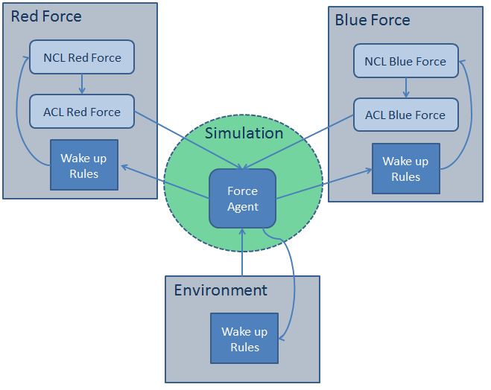
Figure 2: Multi-agent Architecture and Workflow Process [4]

The changes of this architecture refer to the creation of a new agent – Control Agent – and the combination of Red and Blue Agents into the Team Agent. Figure 2 presents the workflow process – the usage of Red Force and Blue Force in separate is mainly for clarity as they are based in the Team Agent. The purpose of merging these two agents stands in the similarity of agent architecture that both presents. Hence, the two teams are at the same level of modeling, not allowing the benefit of one of the teams, avoiding a biased simulation behavior fulfilling the verification requirements for the simulation development process. The NCL and ACL process from the Team Agent refers to National Command Level and Area Command Level. The first one is intended to create a plan based on the perception that is given to him and the conditions that lead to a plan change, and the second one refers to the implementation of the plan, sending it for Force Agent execution.
The added Control Agent is intended to perform several simulations with the given configuration information from the DSS, validating the harbor defense with different strike forces and strategies. This agent is not designed to communicate to the other agents, but only to interact with the application user, being capable of performing a distributed simulation – running a simulation in a remote computer.
5.0 agent architecture
5.1 Team Agent
Like previously explained, the Team Agent is responsible to perform all the modeled behaviors of vehicles, sensors and effectors. To implement this approach, the Team Agent is constituted by:
- Name: That is a distinguish parameter from agent communication;
- Team: Red or Blue;
- Actual position in the environment: 2 Dimension position;
- Plan: Refers to its actual situation (e.g. Surveillance)
- Goal: All action should converge to the goal;
- Radius of perception (e.g. Sensor);
- Travelling Speed: Which is defined as number of cells/step; and
- Domain: Above water sensor; Above water effector; Underwater sensor; Underwater effector, or Platform.
This is the main structure that allows agents to perform its actions leading to its goal fulfillment. The parameter Plan can be described as a set of tasks, which each task is a modeled behavior. Hence, a task could be a simple GoTo movement (short path between two explicit points) or a Survey movement (complex surveillance behavior) making the plan also a complex behavior, composed by all sub behaviors from tasks. A simple plan has associated an objective – the purpose of the plan – and constraints – the conditions that should be fulfilled for a plan changing. An example of that could be a surveillance plan, which only could be changed when an echo from sonar returns an enemy or unknown contact. The plan is also a repetitive action, preventing the vehicles of not moving when all tasks have been performed.
5.2 Scenario Agent
The scenario agent aims in simulate all the conditions of the environment. This agent has a great impact on the performance of the plans of its entities, approaching the real conditions that vehicles are confronted with. A set of conditions are modeled along with the restrictions that should influence the simulation variables: luminosity, wind, sea, and rain. These variables could change the perception of environment or even the travelling speed, turning it into a dynamic context to the simulation, instead of static.
An important aspect that should be noted is that scenario agent doesn’t provide any information about the mapped area where the entities are inserted in. This kind of information is given by an auxiliary file along with the characteristics of vehicles.
5.3 Force Agent
This agent is responsible to gather all the information given by both Team and Scenario agents, and execute the simulation of a hostile context. Its components are:
- Map: Two dimension representation of conflict area;
- Simulation Step: Temporal measure; and
- Internal representation of Plans: Actual plan of each Team Agent.
The parameter Map is where all the plans should be executed. Hence, the Force Agent has an inner representation of the environment, and for each Team Agent executes its plan, simulating the temporal step.
Simulation Step is a simple temporal representation, being just an integer value that is incremented when all the Team Agents execute one temporal step of its plans.
The internal representation of plans will be explained further more within the simulation section. This agent keeps a representation of each Agent plan, giving it the independence that all agents should have from each other’s, being an essential characteristic of MAS.
5.4 Control Agent
The Control Agent, like previously explained, doesn’t have the capability to interact with the other agents inserted in the MAS environment. The main purpose of this agent is to interact with the user, executing several simulations according to the input parameters. Some are given by the DSS and the others by the user. The validation process of a given configuration of entities is made executing several simulations, using different number of threats and each threat with distinct behaviors from simulation to simulation. Hence, the number of executed simulations should be sufficient high to cover all the possible situations of real life warfare, creating a plural set of strike strategies that test the consistency of defense team.
6.0 simulation
6.1 Begin Simulation Process
One definition of the simulation process is: A method for implementing a model over time, and also the executing software on a host computer that models all or part of the representation of one or more simulation entities. The simulation application represents or simulates real-world phenomena for the purpose of training, analysis, or experimentation [2]. Hence, was used a MAS for the modeling process, and implemented a communication protocol that simulates the military hostile environment. The simulation process is divided into three different sections: Begin Simulation; Simulation loop; and End Simulation, which is graphically presented in Figure 4 (Annexes – Sequence Diagram).
6.1.1 Begin Simulation
This section is composed by agent creation of a plan that represents its strategy, which could be, for example: surveillance, strike or defense behavior. Thereafter all agents send its plans to the Force Agent, for the initiation of simulation. Only when Force Agent receives the plans, including the environment state, the simulation can start, and this section is terminated.
6.1.2 Simulation Loop
When the simulation loop is initiated, the Force Agent is responsible for executing the plan of each entity (that could be a sensor, effector or a platform) within the mapped environment. This loop only stops in two cases:
- When certain plan conditions are verified: As said before, a single plan is composed by constrains, which are rules that should be broken to change the actual plan. For example, a simulation should stop and wait for a new plan when a surveillance task perceives an enemy or unknown vehicle. In this case, a message for a plan changing according to the broken constraint is sent to the corresponding agent. When the new plan is built, it is sent again to the Force Agent to proceed with the simulation; and
- When conditions of simulation termination are verified: This happens when a hostile situation terminates. For example, when all elements of Red Team or Blue Team are destroyed or the Red Team entity reach the protected area.
The simulation process was designed like point 1 – stop when a plan constraint is broken – due to the fact of all the executed behaviors in simulation warfare are well trained and planed. Hence, to simulate this immediate changing, the simulation stops and waits for the new plan to be calculated by the entity affected.
6.1.3 End Simulation
This section is intended to terminate the simulation and provide the results of its executions for the Control Agent. When point 2 of simulation loop is verified, the simulation termination is started by sending a message to all entities (Team and Scenario Agents) for the termination of its proceedings. When all the entities are correctly stopped, the results of simulation are prepared to be sent for Control Agent, and the Force Agent is terminated too.
6.2 Configuration
Along with the simulation process, a XML (eXtensible Markup Language) file with information about the simulation configuration with the vehicles’, sensors’, and effectors’ characteristics and strategies should be provided by the DSS. Only when this information is loaded into the platform, the simulation could initiate and execute. The behavior of each agent has to be previously modeled into a script language to be performed when a specific task is called to be executed. All files are vehicle independent, allowing the possibility of its usage in several entities with parameters variation, like speed, which are embodied with vehicle characteristics.
An example of the information that a configuration file should contain is described in the following tables:
Patrol Boat Alpha
Sensors | Navigation Radar
Sensors | GPS Transponder
Sensors | FLIR Camera
Sensors | Sidescan Sonar
Effectors | Long Range Acoustic
Effectors | Optical Disruptor
Effectors | M16A3 rifle
Effectors | Above Water Flash-Bang Grenade
Effectors | Running-Gear Entanglement
Table 1: Patrol Boat Alpha Description

Frigate Sigma
Sensors | Navigation Radar
Sensors | GPS Transponder
Sensors | Daylight Camera
Sensors | Forward-Looking Sonar
Sensors | FLIR Camera
Effectors | Long Range Acoustic
Effectors | Underwater Loud Hailer
Effectors | Hull-Mounted Ship Sonar
Effectors | Above Water Flash-Bang Grenade
Effectors | Running-Gear Entanglement
Table 2: Frigate Sigma Description

All sensors and effectors that each vehicle carries should be specified in the configuration file. This information is loaded to the simulation system and the entities will act, percept, and communicate with each other according with these components specification.

6.3 Communication
Since it is used the JADE framework to model the agents, the communication is based on FIPA-ACL Messages, which is one of the most used languages [11]. The ACL message is a simple ASCII codification, which increases the time processing due to the need of parsing and interpretation/codification of results. The structure specification of ACL message was defined by Foundation for Intelligent Physical Agents [8] as a set of elements: Type of Communicative Act; Participants in Communication; Content of Message; Description of Content; and Control Conversation. The only mandatory element in ACL messages is the performative (Type of Communicative Act), but is expected to also be defined the sender, receiver, and content.
7.0 Implementation
The whole implementation phase isn’t yet finished. The features developed focus on the MAS architecture implementation in order to validate it. The features implemented so far are:
- Multi-agent Architecture: Interaction implementation of simulation structure and MAS properties – environment, agent position variation along time, set of agents, interaction, perception, and reaction;
- Agent Architecture: Implementation of Team’s, Force’s and Scenario’s architecture;
- Communication Protocol: Was implemented a communication protocol using the FIPA-ACL Messages. This protocol allows not only the communication regarding the workflow process presented, but also the communication between agents for coordination and cooperation operations; and
- Interface: The implementation of an interface (Figure 3) was necessary due to validation purposes. In order to validate the agent behaviors through the environment, a simple representation of modeled environment (Land a Sea cells) was made, along with simple representation of agents too.
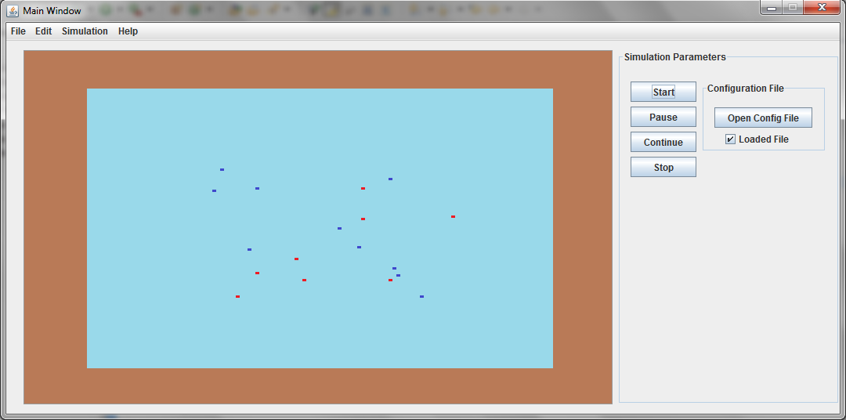
Figure 3 - First test interface (blue team in blue, red team in red, land in brown and water in cyan)
8.0 Future Work
So far the work focused on the development of an architecture to allow the simulation of configurations for surveillance systems for harbor and force protection, which can be used in multiple scenarios. We will now model the plans associated to agent objectives and the transition rules. This approach makes possible the implementation of heterogeneous behaviors not only between teams (Red and Blue), but also between members of the same team, making possible different reactions of different agents to the same situation.
The coordination and cooperation between agents is other component of the simulation that is still being developed. This allows using a group for a simple problem solving, discarding the dissection of the problem into small ones and allocating each one to different agents. This approach is intended to see the problem has a whole and apply the group coordination capabilities to solve the problem more efficiently and effectively.
Since this simulator is an integral part of a higher project, the modular communication is a pre-requirement. In one hand, this simulator should receive the configuration file that describes all the vehicles, sensors, effectors, objectives, strategies and environment for the simulation execution, and for another, feed the DSS with the results of the simulation. This bidirectional communication between modules is made recurring to the XML files.
Finally, the implementation of Control Agent will allow the possibility to run multiple simulations with different inputs for defense force validation. To develop this feature, strike strategies should be used for the Red Team modeling along with the flexibility of number of entities parameterization for the strike force.
9.0 conclusions
The use of MAS for the simulation process in a military domain is adequate, since it allows the behavior modeling of each entity involved in the scenario. This approach is capable of giving independence to all agents, allowing the execution of appropriate individual behaviors, not being influenced by the general panorama of the simulation, but giving response to local changes which are the normal way of perception and action. This represents a shift from the so common differential equations that are modeled mathematically, to the specification of individuals, approaching this way from the real world conditions. The military warfare is not a result of general modeled behavior, but the result of entities interaction that were modeled individually.
The multi-agent architecture presented proves to be an efficient approach due to the Force Agent that is responsible for the simulation execution. This central execution is intended to be effective because the number of messages was reduced to the minimum possible, and so the expected processing time of those messages. The messages that are sent refer to the plans of each agent to Force Agent and its consequent reply, and the normal communication of agents for coordination purposes. If the execution of plans was made by the agents individually, it would increase the number of mandatory messages to the environment update, and would constrain the temporal execution of simulation.
The central execution of plans allows also the synchronous pause of simulation, greatly increasing the usability. If the execution of plans was distributed through all agents, the only way to pause the simulation was informing each one to stop, that could raise timing problems – one agent could update its state several times, when others were being stopped – in case of a high number of entities.
This work is done in the framework of the NATO SAFEPORT project. This project aims to assist in the selection of the best configuration of surveillance systems for harbor and force protection which one of the components is the DSS (Decision and Support System) that will use a simulation environment. This simulation environment will interact with the DSS in order to play out the configurations and feedback the results. The DSS will then be able to present to the end user a set of possible defensive configuration deployments.
ACKNOWLEDGMENTS
We acknowledge the contribution of the others SAFEPORT partners: EDIsoft; the Faculty of Sciences of the University of Lisbon (FCUL), with the Operations Research Center (CIO) and the Laboratory of Optics, Lasers and Systems (LOLS); and the Geophysics Centre of Évora (CGE) of the University of Évora (UÉ). NATO is SAFEPORT’s sponsor, under the aegis of the Emerging Security Challenges Division (ESCD) and the Defense Against Terrorism Program of Work (DAT PoW) which the Portuguese Navy leads.
references
- A.J. Rodrigues, “Minimizing Port Security Risk”, University of Lisbon, Portugal, RTO-SCI-247, Italy, 2012.
- Department of Defense. 1998. “Department of Defense Modeling and Simulation (M&S) Glossary”, DoD 5000.59-M.
- Durfee, E. H., Lesser, V. R., and Corkill, D. D. 1989. “Trends in Cooperative Distributed Problem Solving”. IEEE Transactions on Knowledge and Data Engineering, 1 (1): 63-83.
- H. Edward Hall, Norman Z. Shapiro, Herbert J. Shukiar. Rand. 1985. “Overview of RSAC system software: a briefing”, Santamonica, CA.
- S. Franklin and A. Graesser. 1997. “Is it an Agent, or just a Program?: A Taxonomy for Autonomous Agents”, Lecture Notes in Computer Science, 1193:21–36.
- J. Ferber. 1995. “Les Systèmes Multi-Agents. Vers une Intelligence Collective”, InterEditions, Paris.
- N. Ferrand. 1996. Modelling and supporting multi-actor spatial planning using multi-agents systems, Third NCGIA Conference on GIS and Environmental Modelling, Santa Barbara.
- Foundation for Intelligent Physical Agents. 2000. “FIPA ACL Message Structure Specification”. FIPA TC C.
- A. Ilachinski. 2004. “Artificial War: Multiagent-Based Simulation of Combat”, World Scientific Press.
- N. R. Jennings. 1999, “On agent-based software engineering. Artificial Intelligence”, 117(2):277-296.
- M. Koes, I. Nourbakhsh, and K. Sycara. 2004. “Communication efficiency in multi-agent systems”. In Proceedings of ICRA 2004, volume 3, pages 2129 – 2134.
- Lee, Kyu et al. 1985. ”A High-Level Design Language for Programmable Logic Devices”. VLSI Design (Manhasset NY: CPM Publications) 6 (6): pp. 50–62
- E. Oliveira. 1999. “Applications of intelligent agent-based systems. In Proceedings of SBAI”, Simpósium Brasileiro de Automação Inteligente, pages 51–58, 1999.
- R. D. Smith. 1998. “Essential techniques for military modeling and simulation”. In Winter Simulation Conference’98, pages 805– 812.
- M. J. Wooldridge. 2002. “Introduction to multiagent systems”, Wiley
- M. J. Wooldridge and N. R. Jennings. 1995. “Intelligent agents: Theory and practice”. Knowledge Engineering Review, 10(2):115–152.
- F. L. Bellifemine, G. Caire, and D. Greenwood, “Developing Multi-Agent Systems with JADE”, Wiley, 2007.
Annexes
Sequence Diagram
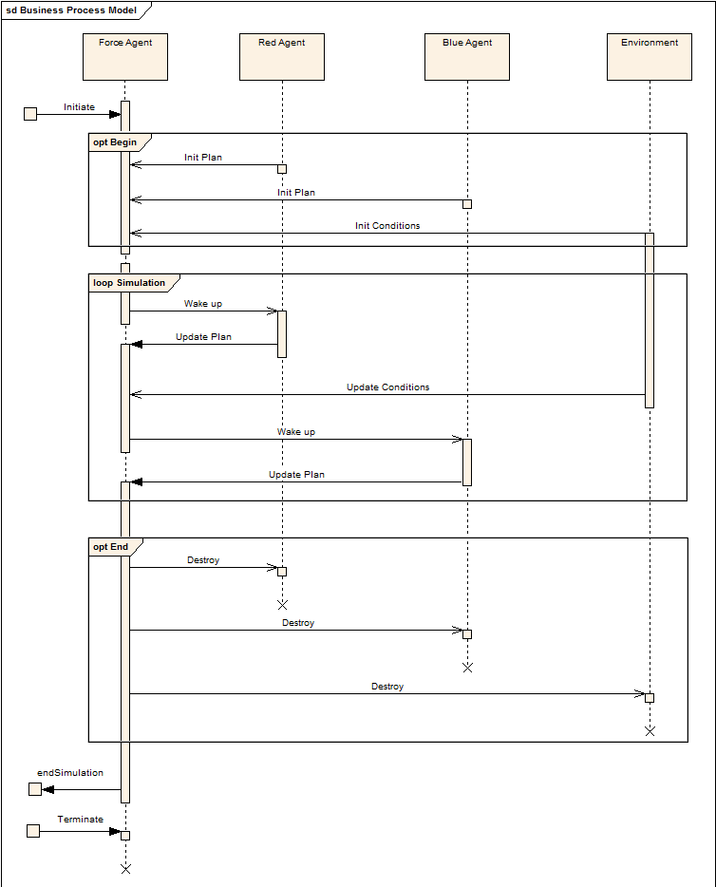
Figure 4: Sequence Diagram of Agents’ Interaction

